***Virginia Junior Classical League***

*presents this*

Certificate of Excellence

*to*

Hana Parece

*of*

L.C. Bird High School

*for*

*3rd Place in Greeting Card*

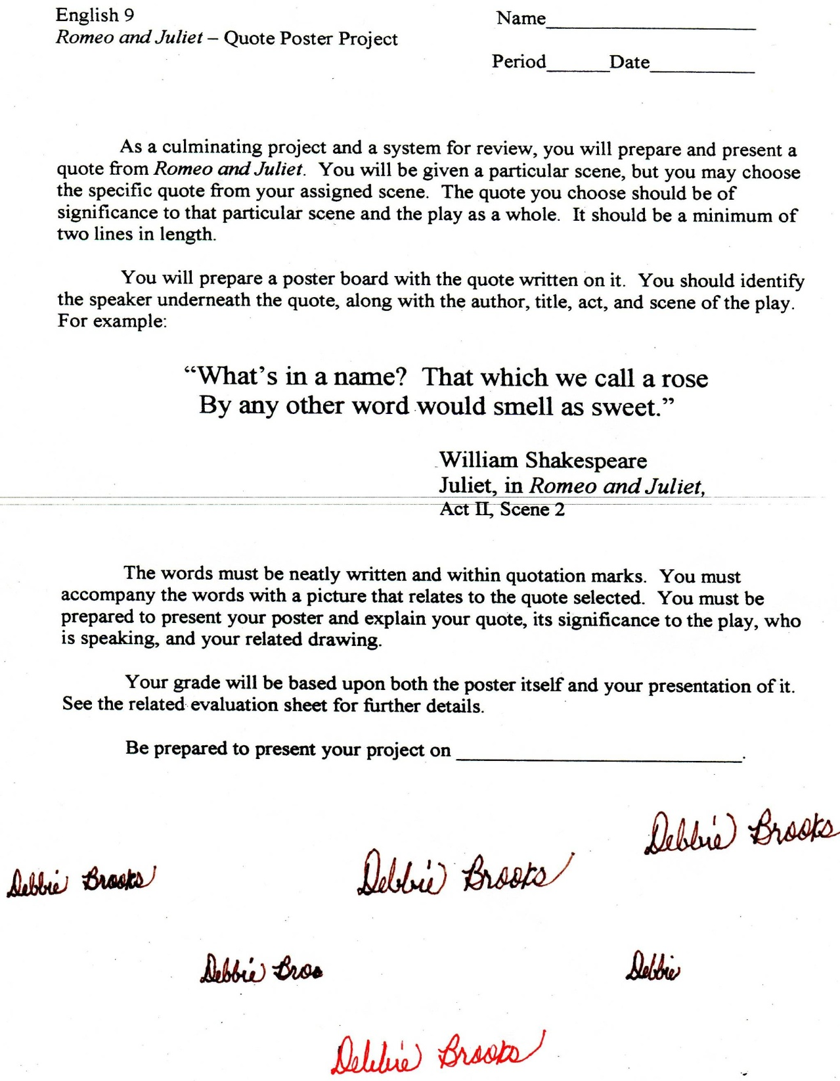

Microsoft Office Signature Line...

*a.d. viii Kal. Dec. MMDCCLXVII A.U.C. 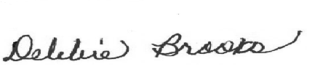*

***Virginia Junior Classical League***

*presents this*

Certificate of Excellence

*to*

Jacob Dutton

*of*

L.C. Bird High School

*for*

*4th Place in Felt*

**

Microsoft Office Signature Line...

*a.d. viii Kal. Dec. MMDCCLXVII A.U.C. *

***Virginia Junior Classical League***

*presents this*

Certificate of Excellence

*to*

Madison Wynn

*of*

L.C. Bird High School

*for*

*4th Place in Oil*

**

Microsoft Office Signature Line...

*a.d. viii Kal. Dec. MMDCCLXVII A.U.C. *

***Virginia Junior Classical League***

*presents this*

Certificate of Excellence

*to*

Julian Dixon

*of*

L.C. Bird High School

*for*

*5th Place in Literature*

**

Microsoft Office Signature Line...

*a.d. viii Kal. Dec. MMDCCLXVII A.U.C. *

***Virginia Junior Classical League***

*presents this*

Certificate of Excellence

*to*

Hana Parece

*of*

L.C. Bird High School

*for*

*5th Place in Maps*

**

Microsoft Office Signature Line...

*a.d. viii Kal. Dec. MMDCCLXVII A.U.C. *

***Virginia Junior Classical League***

*presents this*

Certificate of Excellence

*to*

Nicholas Weinman

*of*

L.C. Bird High School

*for*

*5th Place in Mosaics*

**

Microsoft Office Signature Line...

*a.d. viii Kal. Dec. MMDCCLXVII A.U.C. *

***Virginia Junior Classical League***

*presents this*

Certificate of Excellence

*to*

Sara Flores

*of*

L.C. Bird High School

*for*

*8th Place in Charts*

**

Microsoft Office Signature Line...

*a.d. viii Kal. Dec. MMDCCLXVII A.U.C. *

***Virginia Junior Classical League***

*presents this*

Certificate of Excellence

*to*

Nicholas Weinman

*of*

L.C. Bird High School

*for*

*8th Place in Impromptu Art*

**

Microsoft Office Signature Line...

*a.d. viii Kal. Dec. MMDCCLXVII A.U.C. *

***Virginia Junior Classical League***

*presents this*

Certificate of Excellence

*to*

Sara Flores

*of*

L.C. Bird High School

*for*

*8th Place in Literature*

**

Microsoft Office Signature Line...

*a.d. viii Kal. Dec. MMDCCLXVII A.U.C. *

***Virginia Junior Classical League***

*presents this*

Certificate of Excellence

*to*

Miranda Mozingo

*of*

L.C. Bird High School

*for*

*9th Place in History*

**

Microsoft Office Signature Line...

*a.d. viii Kal. Dec. MMDCCLXVII A.U.C. *

***Virginia Junior Classical League***

*presents this*

Certificate of Excellence

*to*

Julian Dixon

*of*

L.C. Bird High School

*for*

*10th Place in Dolls*

**

Microsoft Office Signature Line...

*a.d. viii Kal. Dec. MMDCCLXVII A.U.C. *

***Virginia Junior Classical League***

*presents this*

Certificate of Excellence

*to*

Jacob Dutton

*of*

L.C. Bird High School

*for*

*10th Place in Geography*

**

Microsoft Office Signature Line...

*a.d. viii Kal. Dec. MMDCCLXVII A.U.C. *

***Virginia Junior Classical League***

*presents this*

Certificate of Excellence

*to*

Amer Amr

*of*

L.C. Bird High School

*for*

*10th Place in Literature*

**

Microsoft Office Signature Line...

*a.d. viii Kal. Dec. MMDCCLXVII A.U.C. *